Question 3: Online Shopping System – Sequence Diagram Scenario: An online shopping application allows customers to browse products, add items to a cart, place orders, and make online payments. After successful payment, inventory is updated automatically and an order confirmation email is sent. If payment fails, the customer is prompted to retry. Warehouse staff process confirmed orders for shipping. Customers can track their order status. The payment gateway validates transactions securely. Discounts are applied automatically during checkout. Customer support handles order cancellation requests. The company wants to understand the interaction between system objects during purchase.
Lab Activity: Develop a Sequence Diagram for the order placement process. give uml 8 diagram for this question
1. Use Case Diagram
The Use Case Diagram shows the main functions of the online shopping system and the users involved. The customer can browse products, add items to the cart, place orders, make payments, track orders, and request cancellations. Warehouse staff process shipping, while customer support handles cancellation requests.
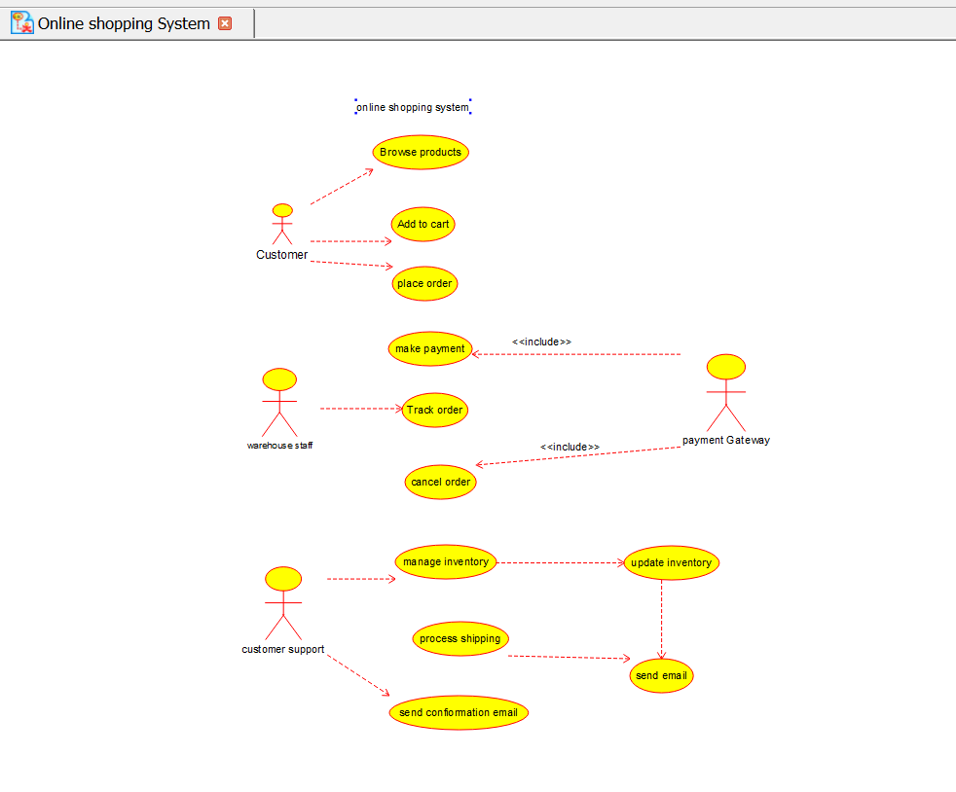

2. Class Diagram
The Class Diagram represents the main classes in the system, such as Customer, Product, Cart, Order, Payment, Inventory, and Warehouse Staff. It shows the attributes, methods, and relationships between these classes. It describes the static structure of the online shopping system.
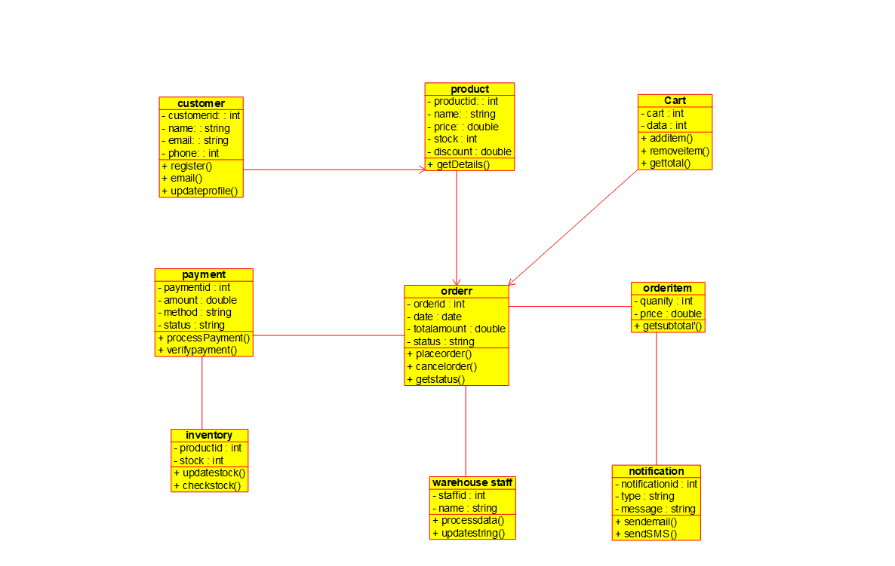

3. Sequence Diagram
The Sequence Diagram shows the order of interactions during the purchase process. The customer adds products to the cart, places an order, and makes a payment. After successful payment, the inventory is updated and a confirmation email is sent.
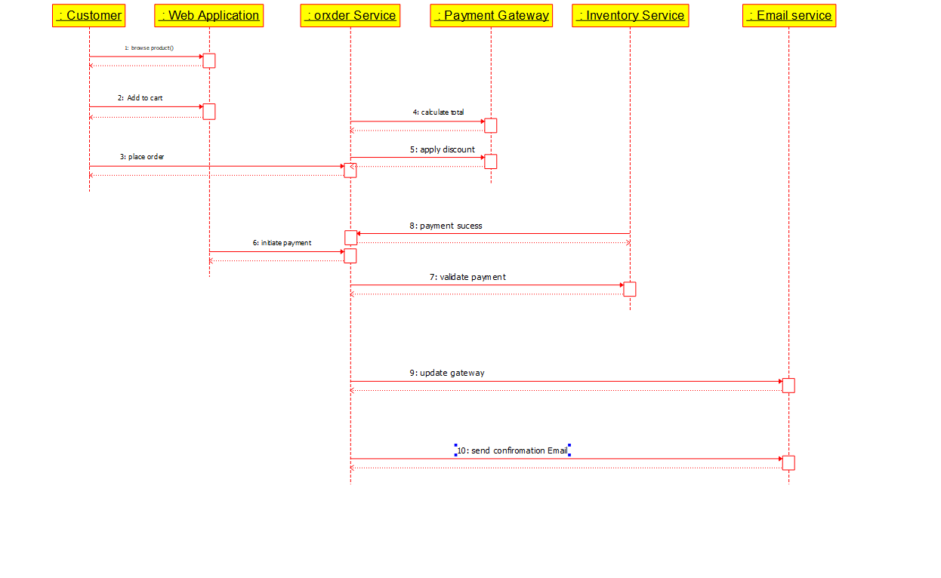

4. Activity Diagram
The Activity Diagram shows the complete workflow of placing an order. It includes browsing products, adding items to the cart, applying discounts, making payments, and processing the order. If the payment fails, the customer is asked to retry.
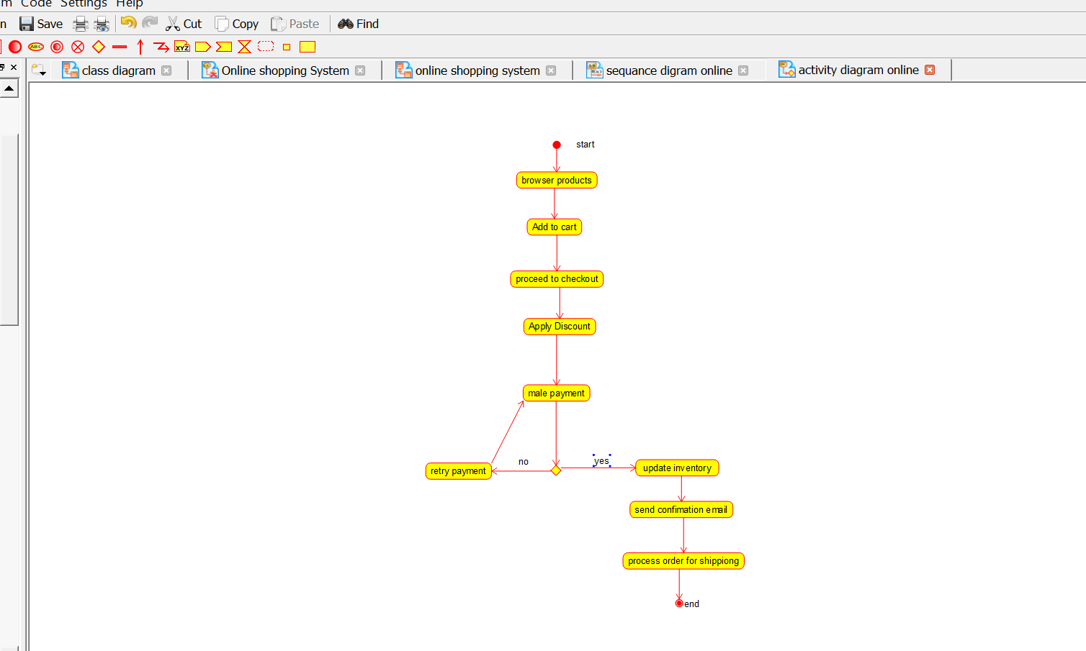

5. Communication Diagram
The Communication Diagram shows how different objects communicate with each other. The Customer, Web Application, Order Service, Payment Gateway, Inventory Service, and Email Service exchange messages. The messages are numbered to show the sequence of communication.
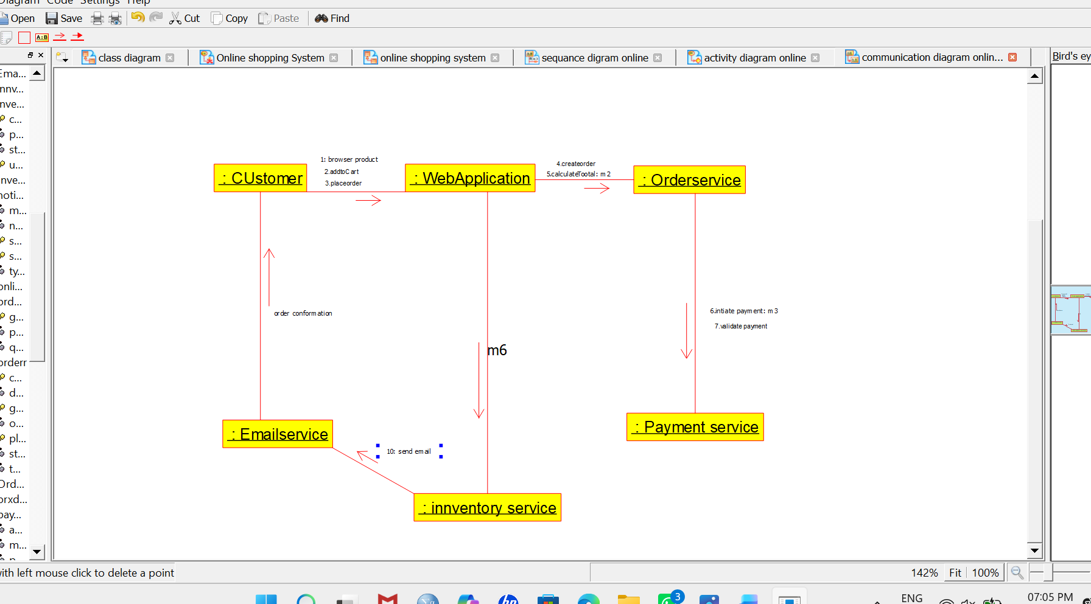
6. State Machine Diagram
The State Machine Diagram shows the different states of an order. An order moves from Cart Created → Order Placed → Payment Processing → Confirmed → Shipped → Delivered. If the payment fails or the order is cancelled, it moves to the respective state.
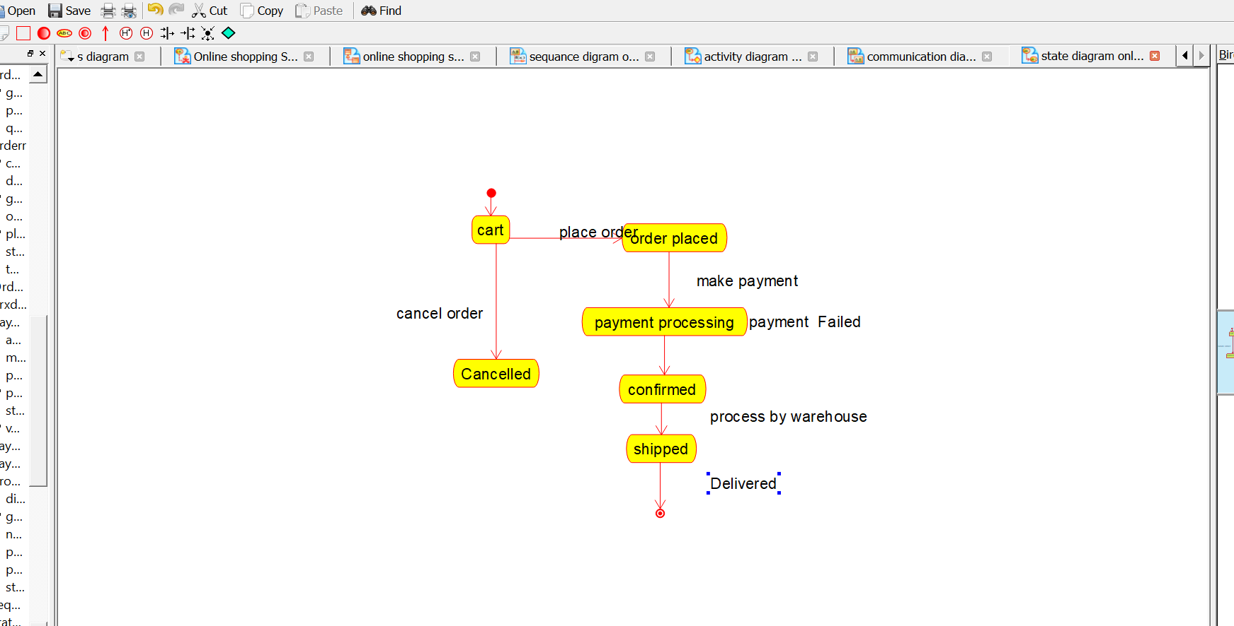

7. Deployment Diagram
The Deployment Diagram shows the physical arrangement of the system. It includes the customer’s device, web server, application server, database server, payment gateway, and email server. It explains how the software components are deployed on different hardware systems.
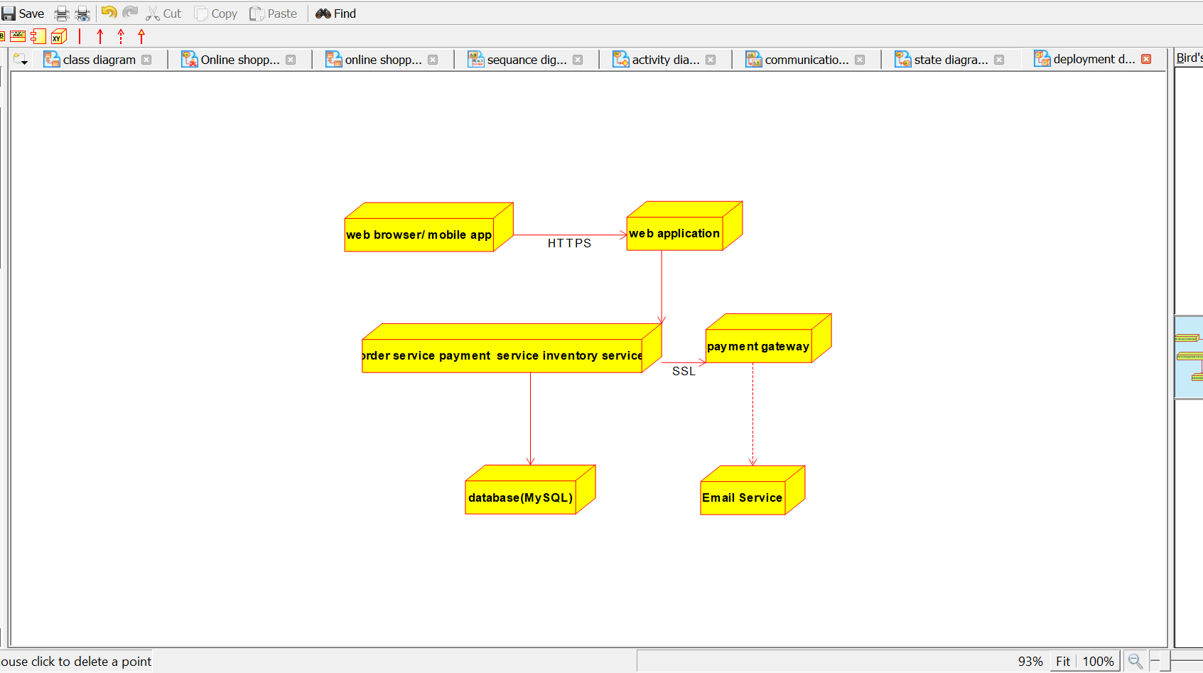
8. Component Diagram
The Component Diagram shows the major software components of the online shopping application. These include the User Interface, Cart Management, Order Management, Payment, Inventory, Notification, and Database components. It shows how these components depend on and communicate with each other.
